1. Before you begin

2. Mobile notifications

3. Movie-ticket price

4. Temperature converter

5. Song catalog

6. Internet profile

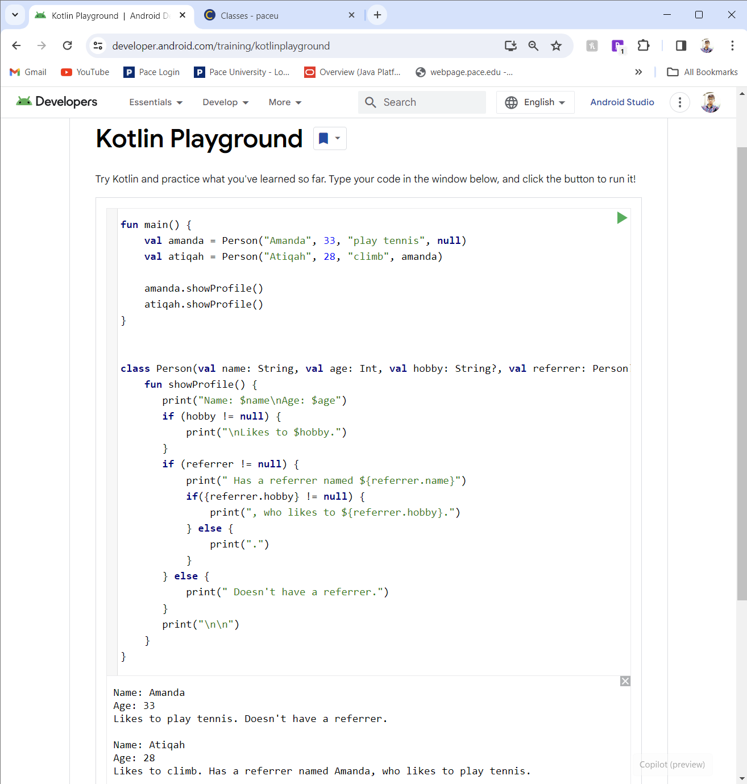

7. Foldable phones

8. Special auction

